NORFOLK COUNTY COUNCIL proposes to make a Temporary Traffic Regulation Order (NTRO7948) affecting the Beach Road from its junction with B1145 High Street for 30m eastwards in the PARISH OF MUNDESLEY to facilitate new connection works by Anglian Water.

The road will be temporarily closed (except for access) from 14th to 16th May 2024 for the duration of the works expected to be about 3 days within the period.

Alternative route is via: High Street, Knapton Road, Water Lane, Paston Road, Beach Road.

If necessary, the restriction could run for a maximum period of 18 months from the date of the Order.

Penalty: £1000 maximum fine on conviction and/or endorsement for contravention.

In the event of the start date being delayed the new start date will be displayed on site in advance.

The team dealing with enquiries at Norfolk County Council is North Area Streetworks (Community and Environmental Services Department) contactable by telephone at 0344 800 8020 or email at streetworks@norfolk.gov.uk. Details are also available at https://one.network.

Dated this 3rd day of May 2024.

Katrina Hulatt
Director of Legal Services (nplaw)
County Hall
Martineau Lane
Norwich
NR1 2DH

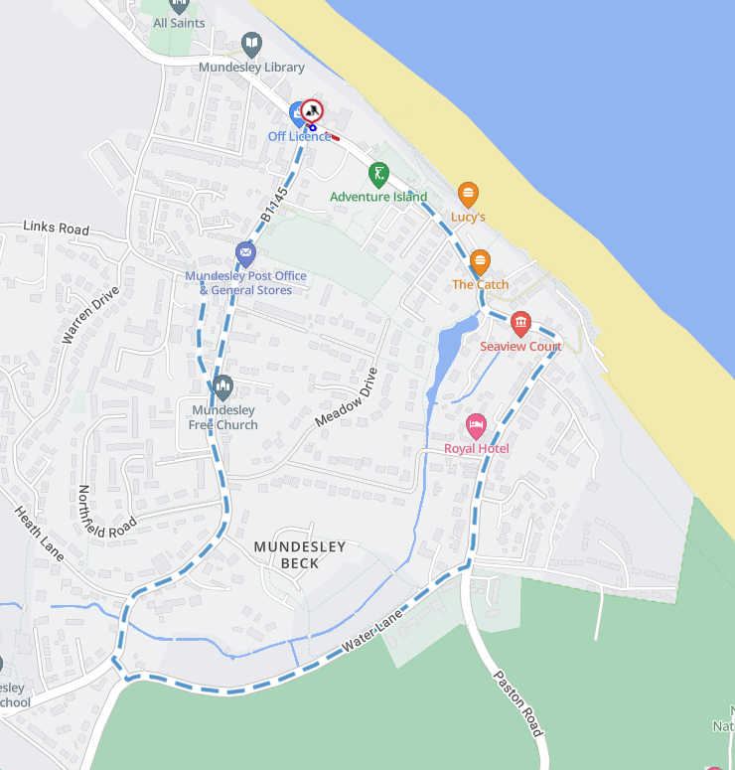
Imagery © 2023 MapTiler | Imagery © 2023 Hexagon | © MapTiler © OpenStreetMap contributors

