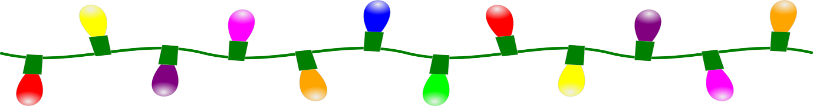
“LIGHT UP MUNDESLEY” REGISTRATION FORM
Name:
Address:
Contact Number:
Email:
Registrations will close on the 20th December.
(please note we must have a completed and returned form in order to enter you for the competition)
Lights will need to be up by the 20th December
 Judging will take place by a panel on the 21st & 22nd December.
The winner will be announced on Christmas Eve.
Win a meal for two at the Royal Hotel
I also understand that my details will be held on file for this event and I have the option to opt out of my personal information being held at any time by contacting the Clerk in writing at the address below.

Please return this form to:
The Clerk at Mundesley Parish Council office, Back Street, Mundesley, NR11 8JJ, or send an email to clerk@mundesley-pc.gov.uk

